Academic Year: 2025-26 | Year: Second Year | Semester: II
PRN No.: 1012411011 | Name: Riddhee Kulkarni
Subject: Python Programming
Assignment No.: 17
Date: 16/02/2026

Lab Assignment: 17
Aim:
Write a program to add two numbers that are given using command line arguments.

Objective:
To understand how to use command line arguments in Python and perform arithmetic operations using user-provided inputs.

Theory:
Command line arguments are values passed to a program at the time of its execution.
In Python, command line arguments are accessed using the built-in sys module.
- sys.argv is a list that stores command line arguments.
- sys.argv[0] contains the program name.
- sys.argv[1] and sys.argv[2] contain the first and second user inputs.
- The float() function is used to convert string inputs into numeric values.
- Exception handling (try and except) is used to handle invalid inputs.

Algorithm:
- Start the program.
- Import the sys module.
- Check if the number of command line arguments is equal to 3.
- If not, display usage message.
- Else, convert arguments into numeric values.
- Add the two numbers.
- Display the result.
- Stop the program.

Pseudo Code:
START
IMPORT sys module
IF length of sys.argv is not equal to 3
PRINT usage message
ELSE
TRY
num1 = convert sys.argv[1] to float
num2 = convert sys.argv[2] to float
result = num1 + num2
PRINT result
CATCH ValueError
PRINT invalid input message
END

Code:
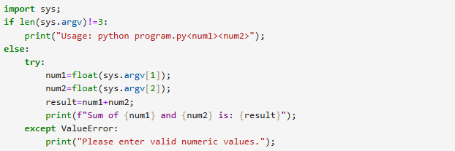

Output:

Conclusion:
Thus, the program to add two numbers using command line arguments was successfully implemented and executed. The program correctly handles valid inputs, invalid inputs, and missing arguments using exception handling.

